Data Driven: Access to Technology
Introduction
Technology is not neutral — it works well for some users and creates friction or exclusion for others. The AccessGuru dataset contains over 3,500 real-world web accessibility violations collected from 448 diverse websites across domains like health, education, government, news, technology, and e-commerce. Each instance is annotated with one of 112 distinct violation types spanning syntactic, semantic, and layout categories defined by WCAG 2.1 guidelines.
As a Datathon participant, your team is tasked with exploring where technology fails, who it excludes, and what barriers exist in digital systems. By analyzing this dataset, you can uncover patterns of inequity, identify hidden assumptions in design, and suggest ways technology can be more inclusive.
This Datathon is your opportunity to dive into real-world accessibility data, explore exclusion points in digital systems, and develop data-driven insights or predictive models that help technology serve everyone more equitably.
Executive summary
We have analysed 3524 entries containing violations real world we accessibility, we have identified systematic patterns of digital exclusion. News/Media domain show the highest violation density primarily driven by colour contrast enhanced. Our recommendation provides ways to mitigate these challenges.
- Which domains (health, education, government, etc.) have the highest number of accessibility violations?
News and Media have highest number of accessibility violations followed by Ecommerce.
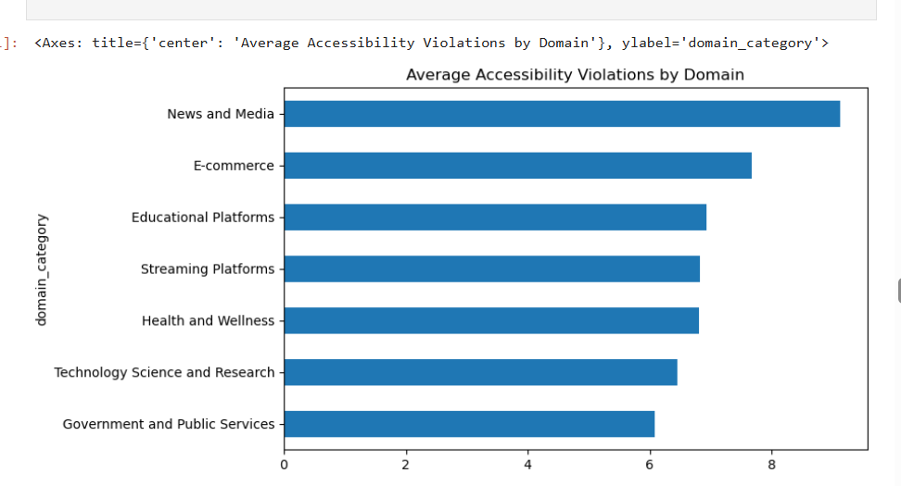
- What violation types are most common across sites or domains?
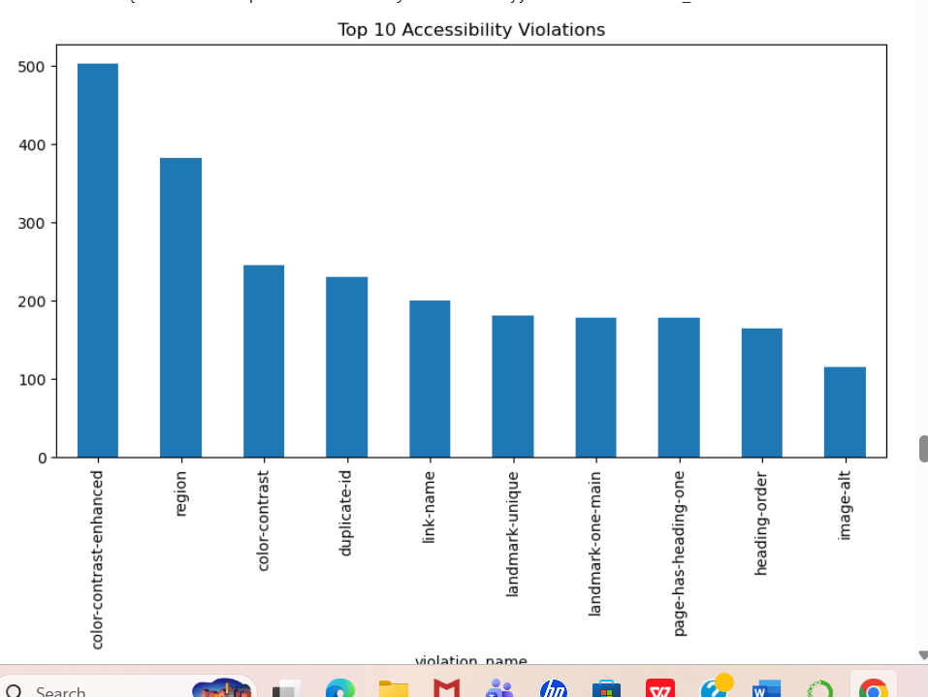

The top type of violations are
- colour contrast (Top)
excludes people with visual impairments.
- Missing region label
Screen reader cannot navigate page structure.

- color contrast that is majorly design issue. There is a need of strong HTML code to rectify these issues.
- Are there patterns in violations by violation category (syntactic, semantic, layout)?
Syntax is the highest in violations among all categories followed by Layout violation. Contrary, semantic is least occurred violation among all. However, syntax have more violations in number, but layout has more serious impact.
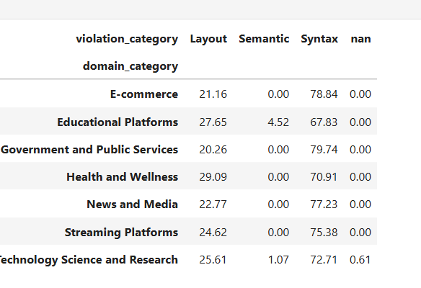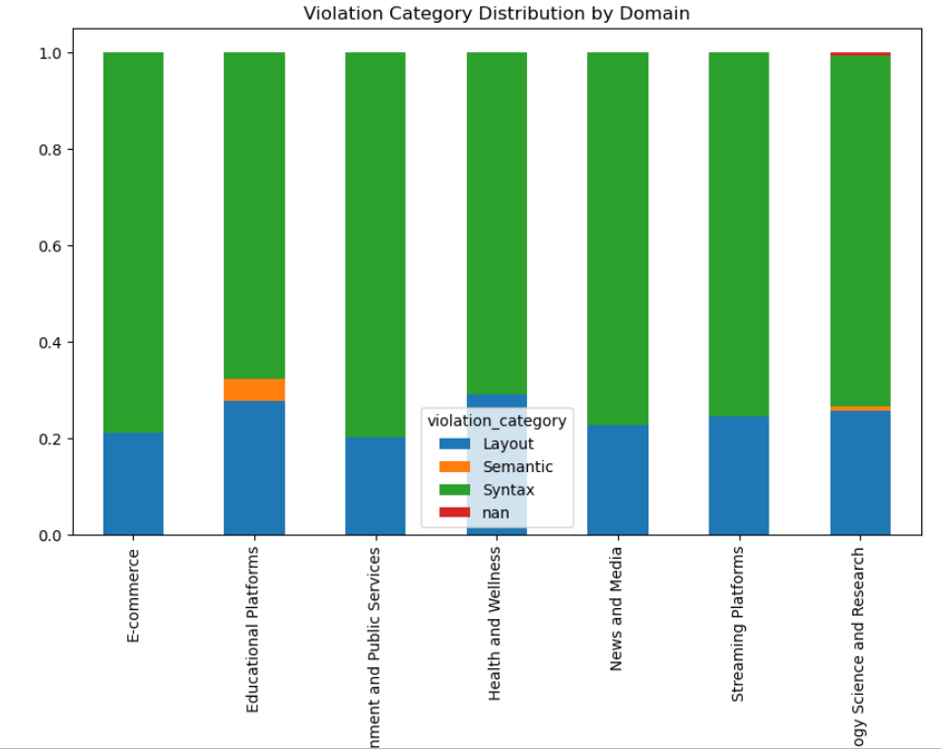

- 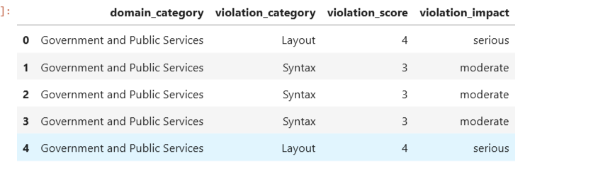
- Identify websites/pages with the most severe accessibility issues.
Our result shows that technology science(spss) has more total violations with high risk rate followed by educational platform (cloudacademy)

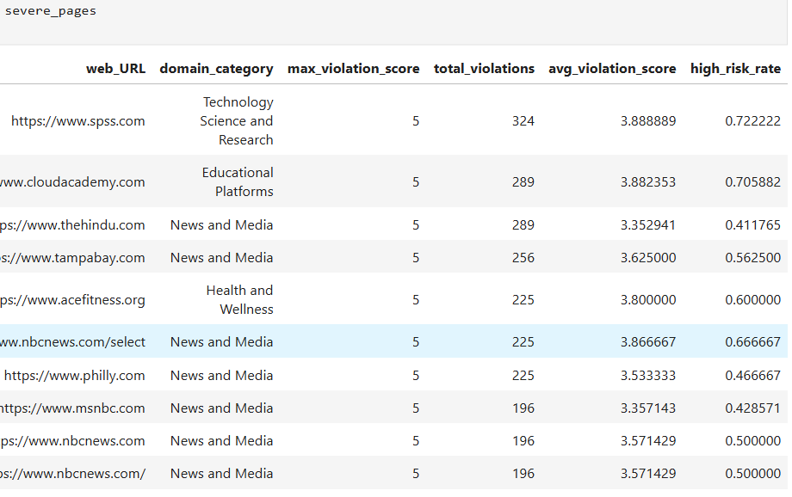

Predictive insight(Random Forest)
Model accuracy: 53.2%
High risk recall= 62%, it can flag majority of high risk violations
High risk perception= 57%

Recommendations
- Inclusion of accessibility in Software development cycle
- News and Media needs to work on their accessibility issue as it is main source of creating awareness among people.
- Syntax and layout issue need to be solved.
- Tie incentive structure of team working on layouts.

